GRISTON PARISH COUNCIL

Parish Clerk & RFO: Sarah Brookes Email: gristonclerk@gmail.com

Minutes of the Griston Parish Council meeting held at GFSL Boardroom, HMP Wayland, Thompson Road, Griston, Thetford, IP25 6RL on Tuesday 9th December 2025 at 7:00pm

In attendance: Cllrs Shane Barber (Chair), Keith Mace, John Heath, Bridget Park, Katrina Heath.
Members of the public: 1
Parish Clerk & RFO: Sarah Brookes

- Apologies for absence
- Pecuniary interest or seek dispensations.
  - Cllr J. Heath declared an interest in a forthcoming item on “update on Eastern Attachments & Griston Community Group” due to his position as group leader. The council considered the above interests and it was RESOLVED to grant a dispensation, in the public interest, to enable Cllr J. Heath to remain in the meeting and to speak in relation to this item.
  - Councillors Registers of Interest Forms. Councillors are to submit any changes to Breckland District Council. None submitted.
- Minutes
The minutes of the meeting held on 11th November 2025 were APPROVED as a true and correct record of the meeting and signed by the Chair.
- Matters arising from previous minutes, and consider any further actions.
  - Griston North Ward
    - A response was received from Carbrooke Parish Council following the Clerk’s notification letter. It was RESOLVED that Cllr S. Barber and the Clerk would prepare a draft response and forward it to Carbrooke Parish Council.
  - RLS Computers website migration
    - An update was received from the Clerk regarding communications with the website supplier. Councillors viewed the draft website and it was AGREED that feedback would be provided to the Clerk in advance of the handover. Councillors queried the current domain name and the Clerk confirmed that the supplier is able to redirect the existing website to the new domain for an overlapping period subject to a fee. Councillors considered and APPROVED a quotation from RLS to carry out this work for £45 plus VAT.
    - The Clerk provided an update on progress and timeline to completion. It was RESOLVED that dates and times in January would be arranged for the website handover with the supplier. It was further RESOLVED that the Clerk would confirm whether the gov.uk email address would be set up as part of the handover process.
- Public Participation
  - County Councillor Claire Bowes, no report provided.
  - District Councillor Phil Cowen, no report provided.
  - One member of the public was present.

- Planning
  - The Clerk reported on the Regulation 18 Draft Local Plan consultation. It was noted that the consultation deadline needed confirming. It was RESOLVED that Cllr J. Heath would draft a response to Breckland Council regarding the housing plot development site WAT2 (085) for submission by the Clerk.
  - Consultee responses to planning applications received from Breckland District Council prior to the meeting date.
    - None received.
  - Notification of decisions taken by Breckland District Council.
    - None received.
  - Cllr J. Heath provided an update on Eastern Attachments & Griston Community Group.
    - Council's Statement of Case for the Planning Inspectorate – It was noted that a hearing date of 17th March had been confirmed.
    - Cllr J Heath advised that the Council needed to prepare a Parish Council Statement of Case for submission to the Inspectorate by 5th January 2026.
  - An update was received from Cllr S. Barber on the Neighbourhood Plan including grant funding. The Council was informed of a meeting which had taken place with a planning consultant. It was noted that a start-off grant had been offered to the Council but could not be spent within the current financial year, and it had been requested that these funds be held until FY2026-27.
An initial workshop was proposed for March, with billing in April, after which the Council would assess how, or if, to proceed based on information from the workshop and further advice received. Potential costs for the Neighbourhood Plan were presented and noted.
  - Resilience plan – Cllr S Barber provided an update on resilience planning, based on the NCC framework as presented at the NPTS October Briefing. The Council noted the concept of a resilience plan to assist in the event of a serious incident affecting the village. It was AGREED that the Council is in favour of producing a resilience plan in 2026 and this matter would be included on the January agenda for further consideration.
- Correspondence
  - The Waylander – It was noted that items agreed for submission at the previous meeting had been submitted. Future items include orchard maintenance volunteers and avian flu awareness.
  - Operation Radium Fraud Prevention scheme – The Clerk reported that Norfolk Constabulary had acknowledged the Council’s confirmation to receive updates. No further action was required.
  - Coughtrey Trading Estate Opening Times – the Clerk noted that issues regarding the Estate opening times had been raised with Mr Simon Wood and Cllr Phil Cowen and that the Council was awaiting further information. No updates to report.
  - Government Consultation on Unitary Councils – The Council received information regarding the Government’s statutory consultation on options for unitary councils. It was determined that no formal action was required at this time.
- Financial Update
  - The Clerk provided an update on Unity Banking.
    - It was noted that fees and charges would increase from 1st February 2026.
    - Councillors completed the necessary paperwork to add additional signatories, and it was AGREED that the Clerk would forward the completed form to the bank.
  - Draft budget 2026-27.
    - Cllr S. Barber presented the draft budget for 2026-27 which had been prepared in advance at a separate meeting. The draft budget was received and considered by the Council.
    - It was RESOLVED to approve the final budget for 2026-27 with all councillors in agreement.
  - No update on alternative investment funds was available at the meeting. Cllr S. Barber AGREED to provide the Clerk with contact details to arrange a meeting with a CCLA advisor.
  - An up-to-date Bank Reconciliation & Accounts Update were received.

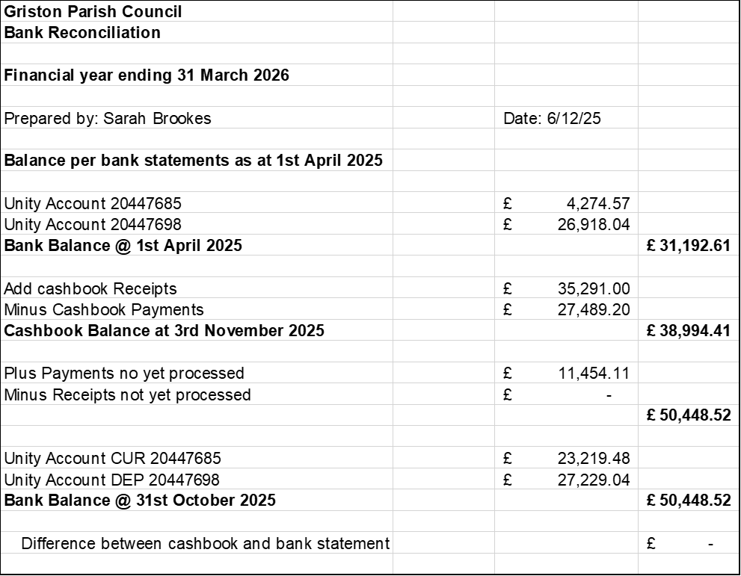

Councillors noted a potential discrepancy with the precept received and AGREED that the Clerk would follow up to confirm the correct amount.
  - The payments and receipts, as presented, were APPROVED by the Council.

Company | Description | Net | Vat | Gross
Playdale | Swing Repairs 50% Deposit | £2448.65 | £489.73 | £2938.38
NPTS | AGAR Assertion 10 Training | £36.00 | £7.20 | £43.20
NPTS | Neighbourhood Plan Training | £52.00 | £10.40 | £62.40
Sarah Brookes | Month 8 Salary | £412.02 | £0.00 | £412.02
HMRC | PAYE Tax/NI | £117.93 | £0.00 | £117.93
Unity | Service Charge 31.12.25 | £6.00 | £0.00 | £6.00
NPower | Electricity 1.11.25 - 30.11.25 | £111.17 | £5.56 | £116.73

- Policies and administration
  - No updated policies were available for approval at this meeting.
  - Training Opportunities – The Council considered training opportunities available through NPTS and RESOLVED to approve the Clerk’s attendance on three upcoming training sessions.
- Village Matters
  - Playground
    - Cllr S. Barber provided an update on swing repairs. The site had been surveyed by Playdale and a quote outline was presented.
    - A quotation for a rope replacement from Playdale for £703.43 + VAT was reviewed and APPROVED.
    - An update was received on progress for the proposed 4-metre mast playground equipment. It was further AGREED that Cllr S. Barber and the Clerk would draft applications for funding and that the mast installation would be delayed until spring to allow funding to be sought from multiple sources. If bids are unsuccessful, the project will be funded from reserves. It was further AGREED that Cllr S. Barber would follow up with Playdale regarding the disposal of existing footings from Congo unit.
  - Orchard Tree Maintenance – the Council reviewed tree trimming and maintenance requirements in the Orchard. It was determined that re-staking and trimming was required and that volunteers would be needed to assist. A date of 31st January 2026 was set, and three councillors volunteered for the work. It was AGREED that a call for additional volunteers would be included in the Waylander. Cllr S. Barber to purchase the necessary four-inch stakes for the work.
  - Avian Influenza
    - The Council noted local areas affected by avian influenza and correspondence received from Trading Standards.
    - It was AGREED that awareness information would be included in the Waylander.
  - Carbrooke Road gates - it was noted that signage is the only outstanding item to finalise billing and grant funding obligations. The Clerk provided an update on communications with the supplier and confirmed that two separate invoices had been received as requested.
  - The Council received an update on the SAM 2 Speed Awareness Monitor. It was RESOLVED to approve expenditure of £41.36 plus VAT for a replacement battery and £15 plus VAT for a replacement connection lead.
- Public Participation (10 minutes)
A member of the public thanked the councillors for their work and wished them a Merry Christmas.
- Items for the next agenda
The following items were suggested for the next agenda:
  - Streetlighting tender
  - Replacement of flower tubs outside the village sign

The meeting closed at 20:59.

Signed: Dated:

