GRISTON PARISH COUNCIL

Parish Clerk & RFO: Sarah Brookes Email: gristonclerk@gmail.com

Minutes of the Griston Parish Council meeting held at GFSL Boardroom, HMP Wayland, Thompson Road, Griston, Thetford, IP25 6RL on Tuesday 11th November 2025 at 7:00pm

In attendance: Cllrs Shane Barber (Chair), Keith Mace, John Heath, Bridget Park, Pete Lake.
Members of the public: 3
Parish Clerk & RFO: Sarah Brookes

- Apologies for absence
Apologies were accepted for Cllr K. Heath.
- Pecuniary interest or seek dispensations.
  - Cllr J. Heath declared an interest in a forthcoming item on “update on the Eastern Attachments & Griston Community Group” due to his position as group leader. Cllr S. Barber also declared an interest as a group member and having previously been a financial contributor. The council considered the above interests and it was RESOLVED to grant a dispensation, in the public interest, to enable both members to remain in the meeting and to speak in relation to this item.
  - Councillors Registers of Interest Forms. Councillors are to submit any changes to Breckland District Council.
- Minutes
The minutes of the meeting held on 21st October 2025 were APPROVED as a true and correct record of the meeting and signed by the Chair.
- Matters arising from previous minutes, and further actions.
  - An update was received on the noticeboard project.
    - The Council noted the boundary report and discussed the intention to establish a Griston North ward.
    - It was AGREED that suitable wording be prepared to notify Carbrooke Parish Council. It was proposed and AGREED that the Clerk send the notification letter to Carbrooke Parish Council.
  - Further updates were received from the Clerk regarding the ongoing website migration.
    - The Council considered colour schemes for the new Griston website. It was AGREED to go ahead with a blue theme.
    - It was noted that current website imagery has been supplied to RLS Computers.
    - The council noted that it would be useful to clarify the process and steps remaining with the website migration, suggesting that an online call with the provider may be required.
- Public Participation
  - County Councillor Claire Bowes, no report provided.
  - District Councillor Phil Cowen. The council received a response via email prior to the meeting, providing information requested including details of the Local Plan.
  - Two members of the public were present at the start of the meeting and made no comments. A third member of the public joined later in the meeting.
- Planning
  - The Council received the Regulation 18 Draft Local Plan and noted that the formal consultation period will run for 6 weeks from the 31st October. It was AGREED that Councillors would review the document and forward any comments to the Clerk for collation.
  - Consultee responses to planning applications received from Breckland District Council prior to the meeting date.
    - The council noted a planning notification in Griston: PL/2025/1547/DCA – HMP Wayland – Discharge of Condition. It was AGREED that no response was required.
  - Notification of decisions taken by Breckland District Council.
    - None received.
  - Cllr J. Heath provided an update on Eastern Attachments on behalf of the Griston Community Group. It was noted that a court order had been received and that a re-determination of an appeal is awaited. The Council discussed concerns regarding site operating times and HGV arrivals. It was proposed that a letter be sent by the Clerk to the relevant parties regarding these concerns.
  - The Council received an update on the Neighbourhood Development Plan.
    - It was noted that a £5,000 grant would be sufficient to progress the initial stages. It was AGREED that a letter would be sent requesting a grant for phase one of the plan, and that Cllr S Barber would approach the former Neighbourhood Plan team to confirm whether they wish to remain involved.
- Correspondence
  - The Council received an update on the Wayland Partnership from Cllr B. Park. The Council noted the activities of the Partnership.
  - The Council considered items for the next article in The Waylander. It was PROPOSED that the next article include updates on the following subjects:
    - To clarify work being carried out on Stan’s Walk
    - A call for interest in a potential sensory garden project.
  - The Council considered a written request from Norfolk Constabulary regarding support for Operation Radium, a courier fraud awareness campaign. It was AGREED to respond to the letter, include information about the initiative in the Waylander, to sign up to receive trigger alerts, and to enquire with Norfolk Constabulary regarding appropriate access to relevant local Facebook pages.
- Financial Update
  - The Clerk provided an update on progress with updating current bank signatories, noting that a request had been made with the relevant contacts and a response is pending.
  - The Council received an update on the Parish Partnership Scheme 26/27 application regarding a proposed new bus stop.
    - It was noted that the original proposed location was not feasible due to objections from residents. Other options were considered but no formal decision was made.
    - The Council considered the submission of a PPS application for the proposed new bus stop, including any associated funding and next steps. It was AGREED that an application would be submitted.
  - The Council considered draft budget proposals for 2026-27. Cllr S. Barber presented a range of options for consideration including dog and litter bin provision, playground replacements, village seating provision, and wellbeing spaces.
Bins: It was AGREED to replace seven dog waste bins (with green, plastic replacements), to relocate the park entrance bin to the bus shelter, to replace bin “LO3” with a dog waste bin, and to retain the church bin in its current location. It was noted that costs will depend on whether existing posts are fit for purpose.
Playground: An overview of playground replacement projected costs were presented, noting a need to reserve funds for future age-appropriate replacements.
Streetlighting: It was AGREED to replace the full streetlighting fleet with LED units and to write to HMP Wayland and the Ministry of Justice to confirm ownership of footway lights.
Seating: Cllr S. Barber presented findings of a survey of the condition of picnic benches and seating. It was noted that there was a case for repairing or replacing worn equipment. It was AGREED to include seating replacement and additional park seating in the budget.
Wellbeing: The Council discussed the potential requirements of the proposed sensory garden. It was AGREED that the project should be considered within the budget, but no formal decisions were made regarding specific features. It was AGREED that Cllr S. Barber would include a call for participants on the local Facebook page.
  - The Council received an update on alternative investment funds, specifically CCLA. Councillors raised queries regarding fund protection and accessibility and requested that the Clerk follow up. Cllr S Barber agreed to provide a supporting data sheet.
  - An up-to-date Bank Reconciliation & Accounts Update were received.

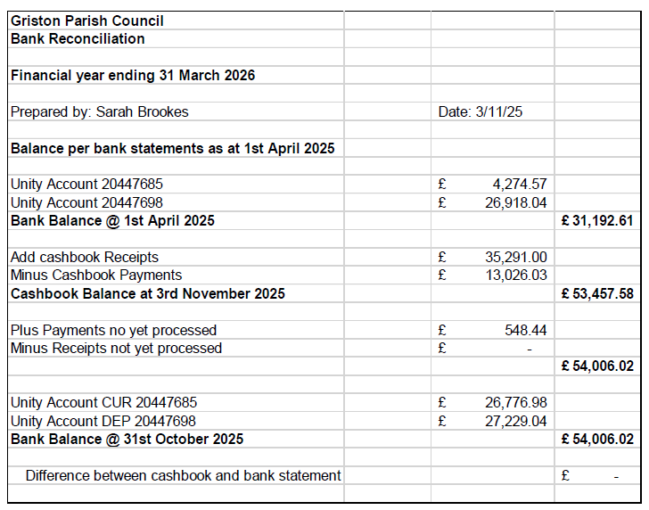
  - The payments and receipts, as presented, were APPROVED by the Council.

Company | Description | Net | Vat | Gross
Miss Sarah Brookes | Month 8 November 2025 Staff Costs | TBC
Unity | Service Charge 30.11.25 | £6.00 | £0.00 | £6.00
Breckland Council | Precept | £13,890.00 | £0.00 | £13,890.00
National Lottery | Community Fund Grant | £7200.00 | £0.00 | £7200.00
Target Trees | Tree Survey | £200.00 | £40.00 | £240.00
NPower | Electricity 1.9.25 - 30.9.25 | £86.02 | £4.30 | £90.32
Wickes | Carbrooke Road Gate (Lock/Chain) | £13.12 | £2.63 | £15.75
Wickes | Carbrooke Road Gate (Lock/Chain) | £11.25 | £2.25 | £13.50
TTSR | Grounds Maintenance | £758.39 | £151.68 | £910.07
Caston Village Hall | Budget Meeting | £30.00 | £0.00 | £30.00
Finding Fitness Ltd | Monkey Challenge Climbing Wall | £7200.00 | £1440.00 | £8640.00
NPower | Electricity 1.10.25 – 31.10.25 | £102.63 | £5.13 | £107.76

- Policies and administration
  - The Council received an updated Data Protection Policy and the accompanying information audit carried out by the Clerk. The policy was APPROVED. It was noted that the link to the Standing Orders on the Parish Council website required updating by the Clerk, and that the asset register would need to be reviewed for 2025.
- Village Matters
  - Streetlights
    - Councillors received an update on progress for the Street lighting maintenance contract and LED replacement works. This matter had been considered earlier as part of budgetary proposals (item 8.c.)
    - Councillors received and APPROVED a quotation for replacement of damaged pole brackets and lanterns at a cost of £1372.02 + VAT.

It was RESOLVED to suspend the standing order and continue the meeting.

  - Playground
    - Councillors received an update on progress towards appointing a new playground inspector. A new inspector and a reserve inspector have been appointed, with the new inspector starting this week.
    - Councillors received an update on the installation of the Monkey Challenge climbing wall which was successfully installed this week and is now in use.
    - Councillors received an update on progress regarding the proposed 4-metre mast playground equipment. It was noted that a response from the supplier to outstanding queries is awaited.
  - The Council received an update on the sensory garden proposal. This matter had been considered earlier as part of budgetary proposals (item 8.c.).
  - The Council considered finalising billing and grant funding for the Carbrooke Road gates. The Clerk confirmed that the project is awaiting completion of the gate signage and that a print order had been placed.
  - The Council received an update on the SAM2 speed awareness monitor. It was AGREED to purchase a second battery, at an estimated cost of £60, to reduce downtime when moving and charging the device. Cllr S. Barber will purchase the battery. It was noted that the monitor is moved regularly and has the option of extracting data if required.
  - An update was received on the condition of dog waste and litter bins. This matter was discussed under budgetary considerations (item 8.c.)
  - An update was received on the condition of picnic tables and benches. This matter was discussed under budgetary considerations (item 8.c.)
- Public Participation (10 minutes)
During public participation, a member of the public suggested that data from the SAM2 speed awareness monitor could be downloaded and used to provide potential insights. The Council noted differing views on the need to do this given that Griston has no known speeding problem, but it was AGREED to include a call for a volunteer to download the data in the next available issue of the Waylander.
- Items for the next agenda
  - Resilience Planning (NPTS)
  - Update of Parish Council's Statement of Case for the Inspectorate re. Eastern Attachments development. FoI regarding noise and odour from Breckland Council.
  - Orchard – tree trimming and maintenance.
  - Decision on draft Budget 2026-27
Meeting Closed: 21:17

Signed: Dated:

